

**TENNESSEE PEST PLANTS**

**Tennessee Department of Agriculture regulates the transport and sale of 13 plant species of 9 different genus. These plants include: Purple Loosestrife, Tropical Soda Apple, Chinese Privet, European Privet, Cogongrass, Amur Honeysuckle, Bush Honeysuckle, Bell’s Honeysuckle, Multiflora Rose, Autumn Olive, Thorny Olive, Giant Salvinia and Tropical Spiderwort. A link to this regulation can be found here:** [**https://publications.tnsosfiles.com/rules/0080/0080-06/0080-06-24.20090413.pdf**](https://publications.tnsosfiles.com/rules/0080/0080-06/0080-06-24.20090413.pdf)**. Ellington Agricultural Center is working to remove these plants from around the property as an example of land stewardship. Invasive plants can out complete native species and disrupt native habitat.**

*Commelina benghalensis*, Tropical Spiderwort

Tropical spiderwort is an aggressive weed that produces aerial (aboveground) and subterranean (belowground) flowers. This results in the production of viable seed both above and below ground. Tropical spiderwort also possesses the ability to root at the nodes. New plants can develop from cut stems. Therefore, light cultivation can often break plant parts and increase the area of infestation.

Although tropical spiderwort is difficult to control, early identification and proactive management can greatly reduce its impact on crop yields.

IDENTIFICATION

Tropical spiderwort has often been confused with spreading dayflower (Commelina diffusa) and Asiatic dayflower (C. communis). However, four characteristics separate tropical spiderwort from the other dayflowers:

Leaf size—The leaf blade of tropical spiderwort is wider and shorter than that of other dayflower species.

Presence of leaf hairs—Dayflower species possess a thick, waxy leaf that lacks hairs (glabrous). Tropical spiderwort, on the other hand, often produces hairs on the young leaves and petioles.

Flower color—The flowers of many dayflower species are blue in color, while tropical spiderwort is more purple/lavender.

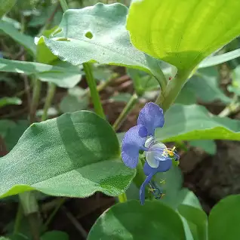 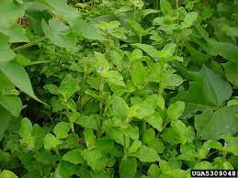 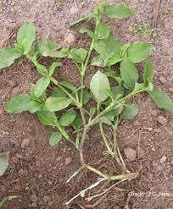

*Elaeagnus pungens*, Thorny olive

Thorny olive is an invasive tough rapidly growing vine-like shrub native to Asia in the oleaster (Elaeagnaceae) family. It is resistant to drought, salt spray, pollution, and damage by deer. It has long shoots that trail out in many directions and can develop an unkempt appearance if not maintained. Showy white fragrant flowers are followed by showy red fruits that attract birds. Young branchlets are covered by brown scales and the stems have thorns that can "hook" onto other plants and structures to climb up.

IDENTIFICATION

Vine-like shrub with brown scaley thorns

Leaves covered with silvery scales below

Petiole and major veins covered with brown scales

Flowers silvery-white and fragrant

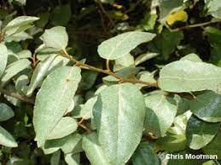 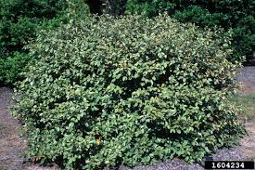 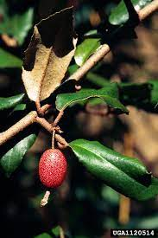

*Elaeagnus umbellata,* Autumn olive

Autumn olive is an invasive deciduous shrub or small tree in the Elaeagnaceae (oleaster) family native to Afghanistan and eastern Asia. It was introduced to the US in the 1800s, and recommended for use as an ornamental plant as well as for creating a windbreak, erosion control, wildlife habitats, and in forest restoration. It can be found growing in disturbed sites such as meadows, grasslands, open fields, roadsides and woodlands. Eradication can be attempted by hand pulling young plants, making sure that all the roots are removed.

IDENTIFICATION

Leaves: The leaves of autumn olive are elliptical, lance-shaped, and arranged alternately on the branches. They are typically silvery-green on the upper side and have a silvery or brownish scale-like covering on the underside.

Fruits: One of the distinctive features of autumn olive is its small, red to orange-red berries. These berries are speckled with silver scales and are often clustered along the branches. They are produced in late summer to early autumn.

Bark: The bark of autumn olive is often gray to brown, and as the shrub matures, it develops a somewhat scaly texture.

Size: Autumn olive can reach a height of 15 feet or more, and its branches can be somewhat thorny.

Habitat: This shrub is often found in disturbed areas, fields, and along roadsides. It is adaptable to a variety of soil types.

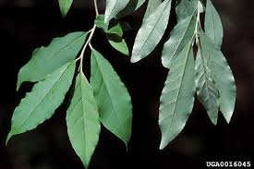 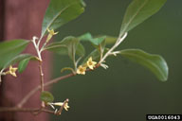 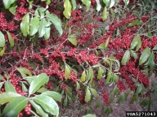

*Imperata cylindrica*, Cogongrass

Imperata cylindrica is an extremely aggressive invader with the capability of invading a range of sites. It forms dense, usually circular infestations that exclude all other vegetation. It is native to Southeast Asia and was accidently introduced into the southeast United States in packing material in the early 1900s. It was also intentionally introduced for erosion control and livestock forage. Tennessee regulates all cultivars including Japanese Bloodgrass.

IDENTIFICATION

Imperata cylindrica is a perennial, colony-forming grass which can grow up to 6 ft. (1.8 m) tall.

Foliage: Leaves have an off-center, whitish midrib and finely serrated margins. Leaves are up to 6 ft. (1.8 m) long, 0.5-0.75 in. (1.3-1.9 cm) wide, stiff, and have a sharp, pointed apex. Rhizomes are whitish, branched, scaly and sharp at the tips.

Flowers: Flower heads are 2-8 in. (5.1-20.3 cm) long, silvery-white and cylindrical.

Fruit: Imperata cylindrica is best identified in the spring by the large fuzzy panicle of flowers and seeds, giving the plant a cottony or silky look.

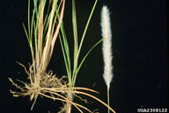 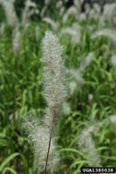 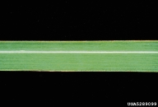

*Ligustrum sinense*, Chinese privet

Ligustrum sinense can tolerate a wide range of conditions. Plants form dense thickets, invading fields, fencerows, roadsides, forest understories, and riparian sites. They can shade out and exclude native understory species, perhaps even reducing tree recruitment. Native to Europe and Asia, *Ligustrum sinense* was introduced in the United States in 1852 as an ornamental plant. It is commonly used as an ornamental shrub and for hedgerows. Tennessee regulated all cultivars of Chinese Privet including Sunshine Privet. We do allow hybrids of this plant.

IDENTIFICATION

Ligustrum sinense is a semi-evergreen shrub or small tree that grows to 20 ft. (6.1 m) in height. Trunks usually occur as multiple stems with many long, leafy branches.

Foliage: Leaves are opposite, oblong, 1-2.4 in. (2.5-6 cm) long, and 0.2-0.6 in. (0.5-1.5 cm) wide. Foliage can be pubescent along the underside of the midvein.

Flowers: Flowering occurs from April to June, when panicles of white to cream flowers develop in terminal and upper axillary clusters. Pollen can cause an allergic reaction in some people.

Fruit: The abundant fruits are spherical and 0.3-0.5 in. (1-1.3 cm) long. Fruit begins green, ripens to dark purple to black, and persists into winter. Birds and other wildlife eat the fruit and disperse the seeds.

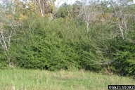 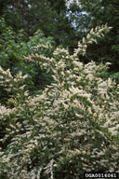 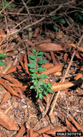 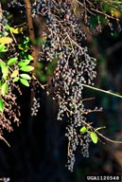 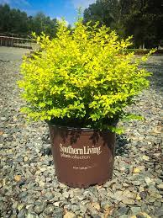

*Ligustrum vulgare*, Common privet, European Privet

Ligustrums can tolerate a wide range of conditions. They form dense thickets invading fields, fencerows, roadsides, forest understories, and riparian sites. They can shade out and exclude native understory species, perhaps even reduce tree recruitment. Native to Europe and Asia, they are commonly used as ornamental shrubs and for hedgerows.

IDENTIFICATION

Ligustrum vulgare is a semi-evergreen shrub or small tree that grows to 20 ft. (6.1 m) in height. Trunks usually occur as multiple stems with many long, leafy branches.

Foliage: Leaves are opposite, lanceolate, 1-2.4 in. (2.5-6 cm) long and 0.2-0.6 in. (0.5-1.5 cm) wide.

Flowers: Flowering occurs from April to June, when panicles of white to cream flowers develop in terminal and upper axillary clusters. Pollen can cause an allergic reaction in some people.

Fruit: The abundant fruits are spherical, 0.3-0.05 in. (1-1.3 cm) long. Fruit begins green and ripens to a dark purple to black color and persists into winter. Birds and wildlife eat the fruit and disperse the seeds. Seed soil viability is about one year. It also colonizes by root sprouts.

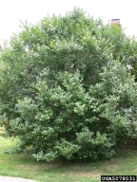 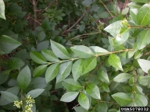 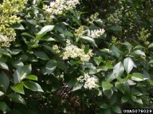 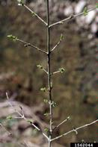

*Lonicera x bella*, Bell's honeysuckle

It invades a broad range of habitats, including forest edges, open woods, fens, bogs, lakeshores, roadsides, pastures and old fields.

They alter habitats by decreasing light availability, depleting soil moisture and nutrients and possibly releasing allelopathic chemicals that inhibit the growth of other plants. Eurasian bush honeysuckles have been widely planted as ornamentals and for wildlife habitat. Commercial propagation continues with many cultivars available from nurseries. Can create a “hybrid swarm” by crossing with the parent plants (L. morrowii and L. tatarica).

IDENTIFICATION

Leaves: Opposite, oval or oblong and untoothed. Leaves may be hairless to downy and green or blue-green. Leaf bases are rounded. Compared to native trees and shrubs, leaves come on 1 to 2 weeks earlier in spring and stay on later in fall.

Flowers: Fragrant, tubular and arranged in pairs at leaf axils. Generally pink and fading to yellow with age, but can vary. The outside of the corolla is smooth. Bloom mid- to late spring.

Fruits & seeds: Red to orange berries occur in pairs at leaf axils and contain many seeds. Readily dispersed by birds.

Roots: Fibrous and shallow.

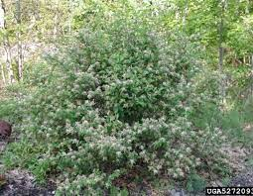 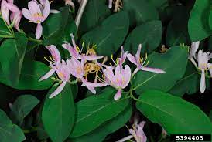 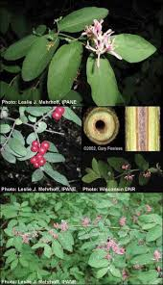

*Lonicera maackii*, Shrub honeysuckle, Amur honeysuckle

Lonicera maackii can form large stands that prevent native shrubs and herbaceous understory plants from growing. The fruits persist on the branches into the winter, when birds feed on them. In the spring, Lonicera maackii is one of the first plants to leaf out, giving it a competitive advantage. This shrub can bear fruit when it is as young as 3 to 5 years old. Though Lonicera maackii has not yet become a major problem in New England, it is very troublesome in the southern and midwestern parts of the country.

IDENTIFICATION

Lonicera maackii is a woody perennial shrub that can grow up to 16.5 ft. (5 m) in height.

Foliage: The oppositely arranged leaves are ovate to lance-ovate in shape and measure 1.3-3.3 in. (3.5-8.5 cm) long. The tips of the leaves are acuminate. The leaves are dark green above and lighter on the lower surface. The veins of the leaves are pubescent.

Flowers: The white flowers are found in erect pairs that are on peduncles shorter than the petioles. The flowers measure 0.6-0.75 in. (1.5-2 cm) long and are bilabiate. The flowers appear on the plant from late May to early June, which is later than the other honeysuckles.

Fruit: The fruit are dark red in color, spherical in shape and measure 0.25 in. (6 mm) in diameter. The fruit become ripe on the plant in the late fall.

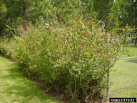 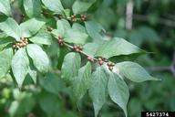 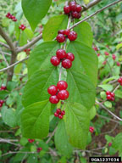 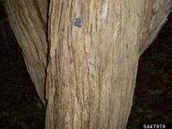

*Lonicera morrowii*, Morrow’s bush honeysuckle, Morrow’s honeysuckle

Lonicera morrowii readily invades open woodlands, old fields, and other disturbed sites. It can spread rapidly due to birds and mammals dispersing the seeds and can form a dense understory thicket which can restrict native plant growth and tree seedling establishment. Lonicera morrowii is a native of eastern Asia and was first introduced into North America in the late 1800s. It has been planted widely as an ornamental and for wildlife food and cover.

IDENTIFICATION

Lonicera morrowii is a multistemmed, upright, deciduous shrub that grows up to 8 ft. (2.5 m) tall. The bark is light brown and often pubescent on young stems. Stems are hollow.

Foliage

The grayish-green leaves are opposite, elliptic to oblong, 2-3 in. (5.1-7.6 cm) long and hairy underneath. Often it is one of the first shrubs to leaf out in the spring.

Flowers

The fragrant paired flowers are tubular, white to cream-colored, 0.75 in. (1.9 cm) in diameter and develop from May to June.

Fruit

The abundant berries are 0.25 in. (0.6 cm) in diameter, ripen to orange or red in color, often persist throughout winter and occur on 0.5 in. (1.3 cm) pedicels.

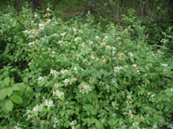 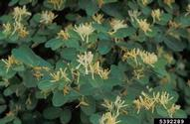 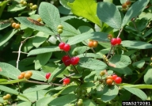

*Lythrum salicaria, Lythrum virgatum* and related cultivars, Purple Loosestrife

*Lythrum salicaria* is a serious invader of many types of wetlands, including wet meadows, prairie potholes, river and stream banks, lake shores, tidal and nontidal marshes, and ditches. It can quickly form dense stands that completely dominate the area excluding native vegetation. This plant can spread very rapidly due to its prolific seed production; each plant can produce up to 2.5 million seeds per year. It can also hybridize with native loosestrife species, potentially depleting the native species gene pool. *Lythrum salicaria* is native to Europe and Asia. It was first introduced into North America in the early 1800s for ornamental and medicinal purposes.

IDENTIFICATION

Lythrum salicaria is a tall, multistemmed (30-50 per plant), perennial forb that can grow up to 10 ft. (3 m) in height.

Foliage: The opposite or whorled leaves are dark-green, lance-shaped, sessile, 1.5-4 in. (3.8-10.2 cm) long and round or heart-shaped at the base.

Flowers: Flowering occurs in July to October, when pink to purplish flowers develop in 4-16 in. (10.2-40.6 cm) long spikes at the tops of the stems. Flowers have 5-7 petals and twice as many stamens as petals.

Fruit: Fruits are capsules that are enclosed in the hairy sepals and contain several reddish brown seeds.

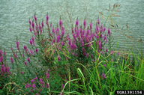 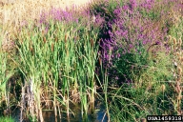 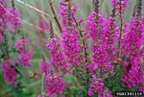

*Rosa multiflora*, Multiflora rose

Rosa multiflora forms impenetrable thickets in pastures, fields, and forest edges. It restricts human, livestock, and wildlife movement and displaces native vegetation. It tolerates a wide range of conditions allowing it to invade habitats across the United States. Rosa multiflora is native to Asia and was first introduced to North America in 1866 as rootstock for ornamental roses. During the mid 1900s it was widely planted as a “living fence” for livestock control.

IDENTIFICATION

Rosa multiflora is a multistemmed, thorny, perennial shrub that grows up to 15 ft. (4.6 m) tall. The stems are green to red arching canes which are round in cross section and have stiff, curved thorns.

Foliage: Leaves are pinnately compound with 7-9 leaflets. Leaflets are oblong, 1-1.5 in. (2.5-3.8 cm) long and have serrated edges. The fringed petioles of Rosa multiflora usually distinguish it from most other rose species.

Flowers: Small, white to pinkish, 5-petaled flowers occur abundantly in clusters on the plant in the spring.

Fruit: Fruit are small, red rose hips that remain on the plant throughout the winter. Birds and other wildlife eat the fruit and disperse the seeds.

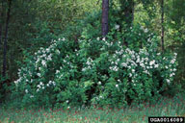 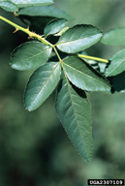 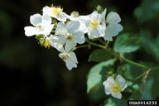 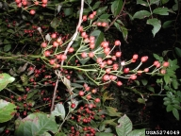

*Salvinia molesta*, Giant Salvinia

After maturing, *S. molesta* forms chains of leaves that run together to form thick mats on the surface of the water. These mats restrict oxygen and light availability causing death of the primary producers and disrupting the aquatic food chain. *S. molesta* is on the Federal Noxious Weed list and can invade most any type of aquatic system. The plant is native to South America and was first introduced into North America as an ornamental.

IDENTIFICATION

Salvinia molesta is an aquatic fern that floats on the surface of the water. Submerged fronds are “stringy” and resemble roots.

Foliage: Floating leaves are 0.5-1.5 in. (2.5-3.8 cm) long, oblong, and vary in color from green to gold to brown. The surfaces of the leaves have rows of arching hairs that look like little egg-beaters. When young, leaves are smaller and lie flat on the surface of the water.

Flowers: This plant does not produce flowers.

Fruit: S. molesta reproduce by spores and by budding of broken stems or attached nodes.

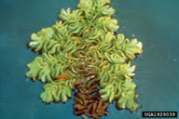 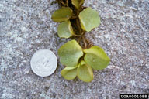 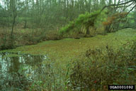

*Solanum viarum*, Tropical Soda Apple

Solanum viarum invades pastures, fields, and parks, but also has the potential to invade open forest and other natural areas. This plant forms thick stands that can be impenetrable to livestock, large wildlife, and humans.

IDENTIFICATION

Solanum viarum is a perennial, shrubby forb that is on the Federal Noxious Weed list. Plants grow to 6 ft. (1.8 m) in height and width.

Foliage: Leaves are broad, 6-8 in. (15.2-20.3 cm) long, 2-6 in. (5.1-15.2 cm) wide, hairy and resemble fig or oak leaves. The entire plant is loaded with 0.75 in. (1.9 cm), straight prickles.

Flowers: Flowering occurs year-round, with most reproduction occurring from September to May. White, 5-petaled flowers grow, in clusters, under the leaves.

Fruit: Fruit are 1 in. (2.5 cm) in diameter and resemble a watermelon.

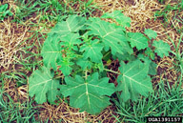 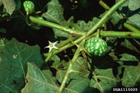 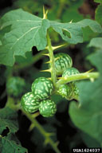

Data and images from invasives.org.

TN Department of Agriculture • Plant Certification Section • 436 Hogan Road • Nashville, TN 37220

Tel: 837-5137 • https://www.tn.gov/agriculture/businesses/plants.html